Cadorna, Joeffrey July 2, 2025
BSCS – 1 (CBM)
MP3: 2D and 3D Array of Students, Scores, and Grades
- Code:
arrStud = [
["Alvey", "Carl"],
["Denzel", "Jeof"],
["Caitlin", "Nini"]
]

# Scores format: [midterm, pre-finals, finals, quiz1, quiz2, ...]
arrScores = [[
[ # Row 0
[97, 85, 89, 90, 92], # Alvey
[90, 100, 100, 95, 93] # Carl
],
[ # Row 1
[98, 96, 95, 92, 94], # Denzel
[94, 100, 95, 90, 91] # Jeof
],
[ # Row 2
[85, 87, 90, 88, 86], # Caitlin
[80, 83, 88, 85, 84] # Nini
]
]]

results = [] # 2D array to store final weighted scores

# Constants for weights
WEIGHTS = {
'midterm': 0.20,
'pre_finals': 0.10,
'finals': 0.20,
'quizzes': 0.50
}

# Process each student and compute their weighted final score
for i in range(len(arrStud)): # Each row
row_result = []
for j in range(len(arrStud[i])): # Each student in row
student_name = arrStud[i][j]
scores = arrScores[0][i][j]

midterm = scores[0]
pre_finals = scores[1]
finals = scores[2]
quizzes = scores[3:] # Remaining scores are quizzes
quiz_avg = sum(quizzes) / len(quizzes)

# Weighted average calculation
final_score = (
midterm * WEIGHTS['midterm'] +
pre_finals * WEIGHTS['pre_finals'] +
finals * WEIGHTS['finals'] +
quiz_avg * WEIGHTS['quizzes']
)

row_result.append((student_name, round(final_score, 2)))
results.append(row_result)

# Print in original row/column format
print("Results:")
for row in results:
print(row)

- Programiz Link: https://www.programiz.com/online-compiler/9K0KoLJxw17Aa

- Narrative:

First off, I have created a 2D array which is the arrStud, which list the names of the students arranged both in the rows and columns, with each row containing the name or a pair of students.
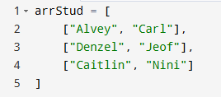

Second, is the 3d list or array, with each element at arrScore[0][i][j] representing the scores for each respective students. Also, the scores are arranged or were place in the order of [midterm, pre-finals, finals, quiz 1, quiz 2, and quiz 3].
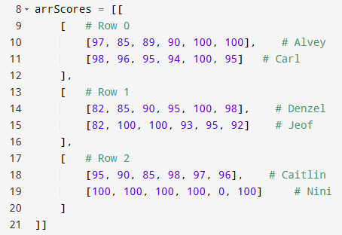
Third is the Constant. Whereby each score component are given a specific weight or percentage to be able to calculate the final grade: with Midterm = 20%, Pre-finals = 10%, Finals = 20%, and lastly the Averages of Quizzes = 50%
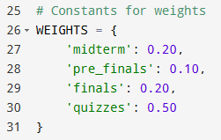
Fourth the Main Logic and Computation Part. On this part, it loops through each of the student, then extracts their scores, then separates the quizzes and calculates the average, then lastly, it computes for the final score with weighted average.
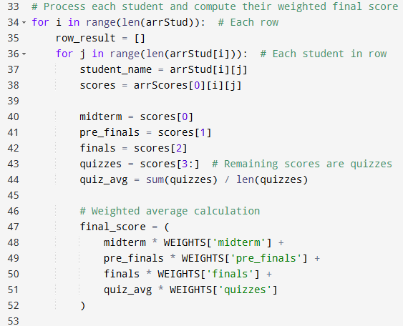
Fifth, for the row_result.append((student_name, round(final_score, 2))), in the inner loop, where the processing of each students take place, it creates a what so called tuple which is (student_name, final_score), it then rounds the final score to two decimal places, then the tuple itself is then appended to row_result, which holds the result for one row of students.
Next is the results.append(row_result), where after the inner loop and once all the students in a row are processed, it now then appends the entire list row_result (containing all student results in that row) to the results list. Then the results become a 2D list that gives the exact structure of the arrStud.
Sixth, is the Output. Where it prints the list of the student’s name in conjunction with their final grade or score in accordance with retaining the structure of arrStudent.
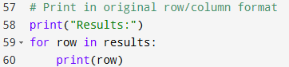
Lastly, here is the Output of program.
